3. Implement Linear Regression.
Aim:
To implement a Linear Regression model using Python to predict the output based on the input data.
Algorithm:
- Start the program.
- Import the required libraries, NumPy and Scikit-learn.
- Create the input data (X) and output data (Y).
- Create a Linear Regression model.
- Train the model using the fit() method.
- Predict the output using the predict() method.
- Display the predicted values.
- Stop the program.

CODE AND OUTPUT:

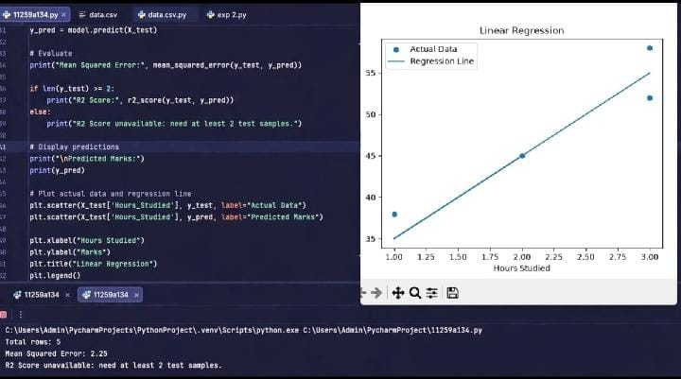
Result:
Thus, the Linear Regression model was successfully implemented using Python, and the output values were predicted based on the input data.

